Friends WCCSP  Membership Form | 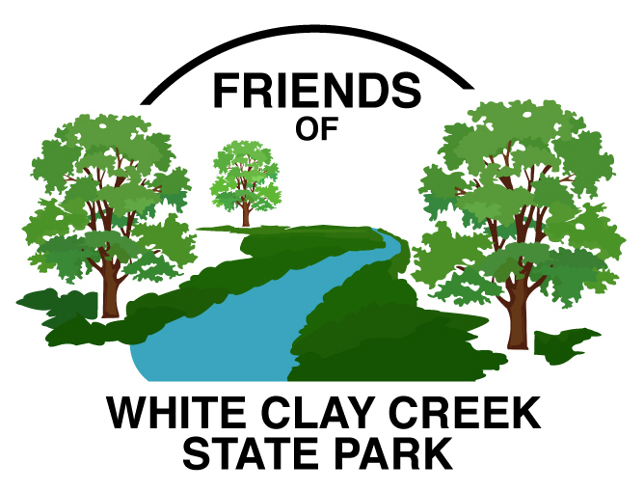

Contact Information
Name
Home Phone
Cell Phone
E-Mail Address

Interests

Tell us which areas you are interested in volunteering:
Trail work (trail construction, maintenance and repair)
Bird Box Monitoring (weekly during nesting season March through October)
Nature Center Staffing (greet visitors on Sundays for one 2.5 hour period Mar-Oct)
50/50 Raffle (Weekly during summer concerts at Carpenter Park)
Native Garden Maintenance and Design (Nature Center and Park Office)
Lead Park Activity (e.g. bird or wildflower walk; other activities of your choosing)
Park Bench Program (assist with assembling, location determination and placement of park benches)
___ Website and Social Media
Special Expertise and/or Other Interests ___________________________________________________

_______________________________________________________________________________________

_______________________________________________________________________________________

_______________________________________________________________________________________

Fill out and then Email this form to fwccsp@gmail.com or

mail to FWCCSP, PO Box 9734, Newark, DE 19714-9734

